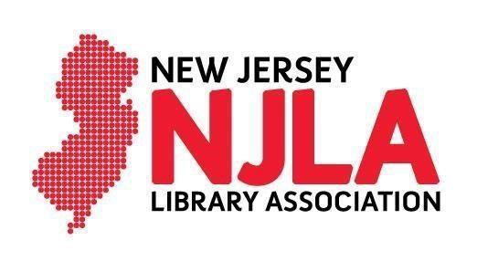 NJLA Public Policy Committee
2018-2019 Legislative Priorities

- Per Capita State Aid (A3801/S2668)
  - Makes $10.5 million supplemental appropriation for increased Per Capita Library Aid from Property Tax Relief Fund
  - Current Assembly Sponsors:
    - Land, R. Bruce (Primary Sponsor); Andrzejczak, Bob (Primary Sponsor); DeAngelo, Wayne P. (Primary Sponsor); Lampitt, Pamela R.; McKnight, Angela V.; Benson, Daniel R.; Chiaravalloti, Nicholas; Holley, Jamel C.; Johnson, Gordon M.; Mejia, Pedro
  - Current Senate Sponsors:
    - Van Drew, Jeff (Primary Sponsor); Greenstein, Linda R. (Primary Sponsor); Stack, Brian P.; Bateman, Christopher; Cryan, Joseph P.
- School Library Media Specialist Required Ratio (A1995/S2394)
  - Requires public schools to hire a certain number of certified school librarians based on a ratio of enrolled students
  - Current Assembly Sponsors:
    - Sumter, Shavonda E. (Primary Sponsor); Wimberly, Benjie E. (Primary Sponsor); Benson, Daniel R. (Primary Sponsor); Caputo, Ralph R.; Giblin, Thomas P.; McKeon, John F.
  - Current Senate Sponsors:
    - Beach, James (Primary Sponsor); Greenstein, Linda R. (Primary Sponsor)

- Information Literacy Curriculum K-12 (A132/S2933)
  - Requires public school districts to include information literacy into the curriculum for grades K-12 with guidelines developed by the Commissioner of Education in conjunction with the State Librarian
  - Current Assembly Sponsors:
    - DeAngelo, Wayne P. (Primary Sponsor); Benson, Daniel R. (Primary Sponsor); Jasey, Mila M. (Primary Sponsor); Sumter, Shavonda E.
  - Current Senate Sponsors:
    - Greenstein, Linda R. (Primary Sponsor)

- Library Network Aid

