New Jersey Library Association
Children’s Services Section
Friday, March 27, 2023 Virtual Meeting Agenda
9:45 a.m.

Section Bylaws
Updating the section bylaws in full requires more than one meeting. Another eboard meeting will be scheduled to discuss further changes.
http://njlamembers.org/sites/njlamembers.org/files/CSSConstbylaws2015final.pdf

NJ Talking Book and Braille Center
This is the first year that the National Library Service for the Blind and Print Disabled will be having a nationwide summer reading program. The TBBC in NJ is excited to participate. There will be a virtual kickoff on June 26.

TBBC outreach recently visited a preschool and demonstrated different ways to read for a younger audience (including reading a print braille book and playing an audio book). If you have any school or library programs that TBBC can be a good fit for, keep them in mind!

NJLA Executive Board
A petition to revive the Circulation and Access Section was successful. It was unanimously voted to start the section once more. The next step is developing best practices to support circulation staff. With enhanced institutional membership, this is a good way to serve more library workers and promote membership.

YASS/GSTBA Update
The GSTBA deliberations are completed for this year. Winners will be announced at conference. The next YASS meeting will be April 21.

NJASL
NJASL spring mini conference theme was Hope & Healing. NJASL continues to work hard on rapidly responding to book challenges. The information literacy bill’s curriculum needs to be written they will be working with the Department of Education on that.

GSCBA
This year’s deliberations are complete. There is some discussion of restructuring GSCBA so that it runs more efficiently and up to date, as this year’s reading was for 2021 books. Some changes are anticipated.

NJALA
NJALA’s conference will be held June 6 at the Mercer County Community College. The theme is “Be the Change.” Please contact njalaconference@gmail.com with any questions. NJALA is also seeking NJALA is also presenters for monthly virtual presentations.

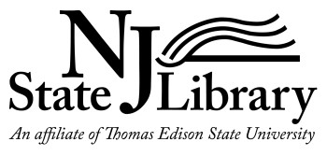
NJSL Report for CSS Meeting, March 31, 2023
Submitted by Sharon Rawlins, Youth Services Specialist for Lifelong Learning, NJ State Library, srawlins@njstatelib.org

The 90 Second Newbery Award Film Festival April 16, 2023 Trenton, NJ -
I still need your help to promote this to get an audience.
Here is a new PDF link to use if you would: https://www.njstatelib.org/wp-content/uploads/2023/02/2023-Film-Festival-2.pdf

Films submitted by NJ youth will be shown at the inaugural 90 Second Newbery Award Film Festival sponsored by the New Jersey State Library on April 16, 2023 at 3 pm at the NJ State Museum’s Auditorium in Trenton (located next to the NJ State Museum). The festival will be hosted by author James Kennedy, founder of the 90-Second Newbery Award Film Festival, and co-hosted by author Chris Grabenstein. The youth filmmakers, their family, friends and anyone interested in short films based on Newbery Award winning books are welcome to attend this free event. You’ll also have the opportunity to meet and have books signed by both Chris Grabenstein (Escape From Mr. Lemoncello’s Library; The Smartest Kid in the Universe, Dog Squad, Shine! and more) and James Kennedy (The Order of Odd-Fish).
Free parking is available on weekends in the State House garage and in lots adjacent to and behind the Museum. Questions? Please contact Sharon Rawlins, Youth Services Specialist, NJ State Library, srawlins@njstatelib.org.
For more information about the 90 Second Newbery Award Film Festival, visit: https://90secondnewbery.com/. To register: https://www.eventbrite.com/e/90-second-newbery-film-festival-2023-trenton-nj-screening-tickets-520988008157

State Librarian’s Monthly Update – March 2023
In an effort to keep the NJ library community informed and involved with what’s happening at the NJ State Library, the State Librarian is sharing monthly update reports for libraries. Check out the March 2023 update here.

SAVE THE DATE: Apply for Solar Eclipse Activities for Libraries (SEAL) Workshops
- June 8, 2023 – Parsippany-Troy Hills Public Library, 10 am – 4 pm
- June 9, 2023 – Gloucester County Library, Mullica Hill, 10 am – 4 pm
Lunch will be provided. Registration application information will be sent out soon.
Space is limited to 35 people due to the hands-on nature of the workshop. Potential participants are requested to provide a short description on the registration form indicating how they will use the workshop training to further STEM engagement activities in their community. Selection of attendees will be based on the strength of each individual application. This workshop is designed to prepare and empower public library staff to facilitate meaningful solar and space science programs for their patrons that build curiosity, knowledge and inspiration. Attendees will receive hands-on training on operating solar telescopes and other methods for direct and indirect solar viewing, best practices for developing and facilitating STEM programs, and how to engage with community partners and library-specific digital resource networks.

CSLP’s Resources on Social & Emotional Health Programs in Public Libraries
The CSLP's Child & Community Well-Being Committee has been collecting examples of library programming that promotes social and emotional health. A compilation of programs submitted by public libraries around the US is now available. It includes an array of library programs for various age groups, from early childhood through seniors, plus multigenerational programs. If you’re looking for program ideas to enhance your “All Together Now” summer programming, or for any time of year, take a look! Find the downloadable Social & Emotional Health Programs at Public Libraries document here:
- In the Additional Content section of the online All Together Now manual, or
- On the Resource List page of the CSLP’s Libraries and Summer Food how-to guide (scroll down to Programming for the link), or
- At this direct link!

Thank you to all the librarians and library workers who contributed their programs. If you’d like to add your program to this listing, use this form to share programs with the CCWB and they will be included in the next edition of Social & Emotional Health Programs at Public Libraries.

StarNet Offering Free Eclipse Glasses to Public Libraries
With an Annual Solar Eclipse in 2023 and a Total Solar Eclipse in 2023, the STAR Library Education Networks SEAL (Solar Eclipse Activities for Libraries) initiative (with major funding support from the Gordon and Betty Moore Foundation) is distributing solar eclipse viewing glasses to libraries in all 50 states and protectorates.
To register you must:
- Be a public library in the U.S., D.C., or in a territory or protectorate
- Agree to distribute glasses for free at eclipse events
- Provide a signed letter from your library director agreeing to the above
Register here: https://www.surveymonkey.com/r/BT58RYV (You must complete the registration in one sitting – you can’t save it and go back to it later)

News/Events/Campaigns from Other Organizations

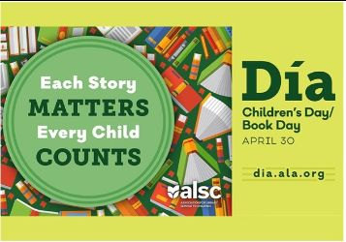
El día de los niños/El día de los libros (Children's Day/Book Day), commonly known as Día, is a celebration everyday of children, families, and reading that culminates yearly on April 30. It emphasizes the importance of literacy for children of all linguistic and cultural backgrounds. This nationally recognized initiative was founded in 1997 by author and poet Pat Mora.

AFA donating children's book on Alzheimer's upon request to public libraries
The Alzheimer’s Foundation of America (AFA) is a national nonprofit organization. They would like to donate copies of an educational children’s book they created and published, Dancing with Granddad: An Alzheimer’s Story for Children and Their Families, written by NJ author Linda Bozzo, to public libraries who are interested in receiving them. The paperback book is available in both English and Spanish. You can request a copy in both English and Spanish if you want.

Dancing with Granddad is designed to be a teaching tool adults can use to have a conversation with a child about Alzheimer’s disease. The book, which is suggested for children ages 5 to 8, takes young readers on the journey of learning in an age-appropriate way that seven-year-old Nia’s Granddad has Alzheimer’s and will need to move to a new home. They also learn that while Nia’s Granddad is changing, the love they have between them never will.

If you’re interested in a copy in English or in Spanish, or both, please request them by emailling Sandy Silverstein, Media Relations Manager at Alzheimer’s Foundation of America, at ssilverstein@alzfdn.org.

ALSC Education Committee Accepting Proposals for Innovative Programs for CE Opportunities
ALSC committees, members, and other interested individuals are encouraged to submit a proposal (ALSC membership is not required).Be part of this exciting professional development opportunity by submitting your program today!

Presentations should provide a valuable learning experience and avoid being too limited in scope. Topics of particular interest based on ALSC member feedback include:
· Age-specific programming suggestions
· Current issues in Intellectual Freedom
· Working in Children’s Services as a new librarian
· Diversity Equity and Inclusion (including accessibility, disability and cultural inclusion)
· Advocacy (both professional and community-focused)
· Grant Work
· Research/Best Practices
· Early Literacy
· SEL-based collection development
· Self-care in challenging times
· Administration and management
· Partnerships
Please note that participants attending ALSC programs are seeking valuable educational experiences; the Education Committee will not select a program session that suggests commercial sales or self-promotion. A presenter stipend is available.

Proposals are accepted and reviewed on an ongoing basis. To submit a program proposal for the ALSC Education Committee, please visit the ALSC website for the submission form and instructions: www.ala.org/alsc/elearning/online-education-proposal

Please contact Sarah Polen, Program Officer for Continuing Education, spolen@ala.org, with questions.

SLJ’s Virtual Middle Grade Magic
It's not too late to register to watch SLJ Middle Grade Magic on demand.

Penguin Random House - Story Time Temporary Open License
Penguin Random House is permitting teachers, educators, librarians, booksellers, and other qualified individuals to create and share story time and read-aloud videos and live events until June 30th, 2023. Learn more here.

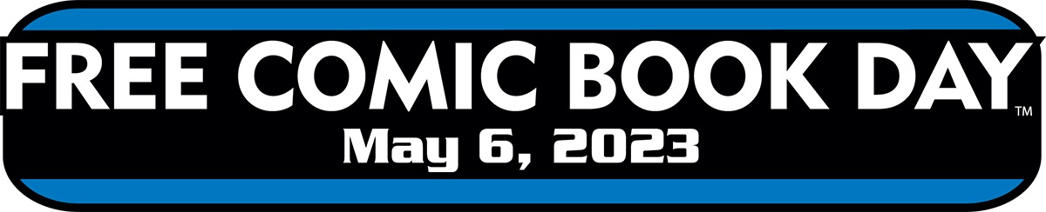
May 6th is Free Comic Book Day! Will your library be participating? Click here to let us know

SAVE THE DATE: Delaware Library offering In-Person TitleTalks with Baker & Taylor April 26, 2023
On Wednesday, April 26, 2023, the Route 9 Library & Innovation Center in New Castle, DE is hosting an in-person TitleTalk with Baker & Taylor. The event will feature talks from publishers about upcoming children's & teen titles, an author keynote, and lots of giveaways! It is open to library staff from surrounding states in addition to those in Delaware. It will be totally free to attendees (including lunch) although registration is required. Register here. If you can’t make it in person you can join the event live via Zoom the day of, as they will be streaming the event LIVE. No registration is necessary for the online option.
Simply log into Zoom to watch, or join via Facebook Live at their page, CATSLibrary
Click on the link to watch on Zoom : https://tinyurl.com/BTCATSTITLETALK

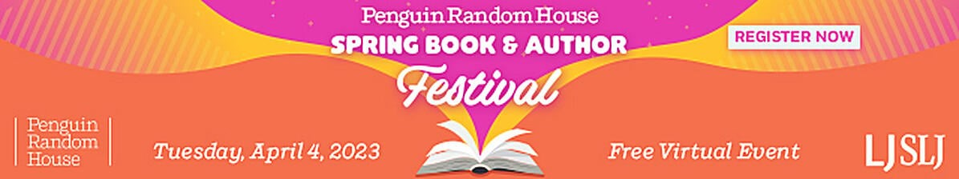On April 4th, join Penguin Random House, Library Journal, and School Library Journal for our Spring 2023 virtual book and author festival, a free day-long event celebrating reading, authors, and librarians everywhere! As we lead up to National Library Week, enjoy a day packed with author panels and interviews, book buzzes, virtual shelf browsing, and adding to your TBR pile.
You’ll hear from many of your favorite authors, whose work runs the gamut from Picture Books to Young Adult titles to the best new Fiction and Nonfiction for adults. There is something of interest for every reader.
To Register.

2023 NJLA Conference
The 2023 NJLA Conference will be held 5/31-6/2 at Harrah’s in Atlantic City. The theme is Sustainably Forward. Registration is now open. Please contact Heather for ideas for CSS’s presence at table space and when you will be able to staff it at heather.kristian@gmail.com

Elections for 2023-2024 Cycle
Voting is open until Friday, April 7 at https://www.njla.org/2023-css-section-election
and the ballot is as follows:
      - Vice President/President-Elect: Jenise Sileo
      - 2nd Vice President: Rachael Trotter
      - Secretary: Teresa Carlton
      - Member-at-Large (2 open positions): Sara Figueroa and Leala Arnold

Any CSS member is eligible to vote. Heather extends a big thank you to all candidates for volunteering their time to run for the CSS board.

In attendance:

Jenise Sileo
Sharon Rawlins
Heather Kristian
Ellen Ryan
Jen Apgar
Lynnette Fucci
Ryan Oxlid
Sara Figueroa
Kris Churchill
Rachael Trotter
Jenna Ingham

The next CSS meeting is Friday, 4/28 at 9:45 a.m.

